**Company Profile**

WebScript Technologies is a Pune based software company established in Feb 2012. Their expertise includes design, development and implementation of software solutions for businesses. WebScript Technologies are working on different platforms including desktop application, web based application, mobile application, microcontroller based application etc. Their team is continuously taking effort to study and analyses latest technologies and adopt them as per requirement in different vertical and horizontal solutions.

* Education
* Civil Projects
* Retailers & Franchises
* Restaurants & Food Chains
* Accounting

We have worked on different domains and developed software solutions to make business processes easy and manageable. WebScript Technologies also focus on have studied each and every aspect of every domain and tried to come up with tangible solution. Also have designed standard set of procedures to gather information, design solution and implement the same. Services provided by WebScript Technologies are

* Software
* Mobile Apps
* Web Design
* Digital Marketing

**Project Title :**

Cable Operator Management System.

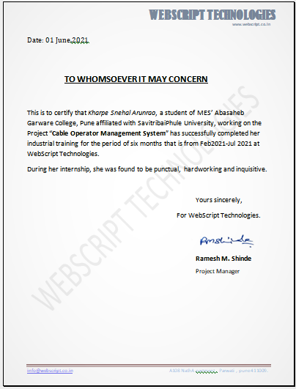

**Project Description :**

Cable Operator Management System is integrated and automation software for cable operators. Cable operators will distribute TV channels to their customers for that they charge some money monthly.

To maintain their customers and number of users this software provides automation. In this COM System they can main their staff member’s details and their customer details .By using this COM System they can divide their areas macro parts to micro parts. By using this system they can meet their business requirements. Cable Operators once they divided their areas into micro parts then they can assign their staff members to take care about their micro part areas.

Cable operators they can maintain their staff members like collection boys, helpers and technicians. All the collection boys will have user id and password. At the end of the every day they will login to the COM System they will feed their collection details and remarks.

By using this COM System they can know about their equipments located on which areas. How many active / non active customers are there? all these details they can view it by using the reports. MIS reports were generated for the month of collections, expenses, pending amount, complaints area wise and date wise, month wise.

Existing System

All the work cable operator used to maintain manually in books , vouchers, collection cards etc.,

**Scope the project:**

To maintain entire operations of the cable operator to be Automated.

● To maintain entire operations of the cable operator to be automated.

● The current system is interactive with the database provides efforts can be made so that the system can adopt the available database features of a new site.

**Proposed System**:

To Automate entire operations of the Cable Operator to maintain their customers details and collections. In this COM System they can maintain their staff member’s details and their customer details. By using this COM System they can divide their areas macro parts to micro parts. By using this system they can meet their business requirements. Cable Operators once they divided their areas into micro parts then they can assign their staff members to take care about their micro part areas. By using this COM System they can know about their equipments located on which areas. How many active / non active customers are there? all these details they can about it by using the reports. Also show the details of each and every activity with change pack details and active plans.

**Software and Hardware Requirement :**

Software Requirements :

Operating system : WINDOWS

Front end : HTML,CSS,JQUERY

Business logic : PHP

Database : MYSQL

Hardware Requirements :

Processer : P3 OR HIGHER

Ram : 512MB

Hard disk : 20GB

**System Design:**

COM System (COMS) is an integrated software deals with Cable Operators. Helps the Cable Operators manage their customers and provides the information about various channels. It makes easy to all operations of the Cable Operators and accurate.

**Masters :**

The information specified in the Master is regarded static, in the sense that it is “Permanent” or non-changing or stable. The updates are infrequent and may be regarded as permanently stored in the Database. The Master Group has functionality to View / Change.

**The master pages will have access to administrator only.**

* 1. Area Master – Cable Operators they will divide their areas macro parts to micro parts like huge area will be divided in to small areas, divisions. In this module admin will add areas and code numbers.
  2. Employee Master -- Admin will add the staff and will provide the privileges as per the staff designation. All the staff members cannot access all the modules. He can add or delete the staff accounts.

3. Customer Master -- Admin will add the new customers those who come in their areas and take new connection. Admin can add or delete the customers and they can view the entire customers list in area wise.

4. Package Master -- Admin will add or modify the Customer Package depends on the Customer request.

**Transaction**:

Transactions deal with dynamic or transient data. Transactions do not affect the MASTER Data. The TRANSACTION Group of functionality is as follows:

1. Collection Screen -- In this module Cable operators will generate the monthly wise collection statement for their particular areas and customer wise. They can generate the date to date collection statements. Staff wise collection statements and area wise statements will generate by using this module.

2. Customer receipt – Customer Payment Receipt generation .

**UML Diagrams:**

* **Entity Relationship Diagram:**

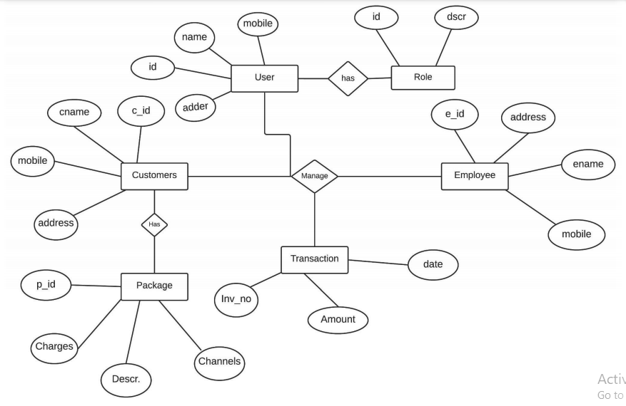

* **Use Case Diagram:**

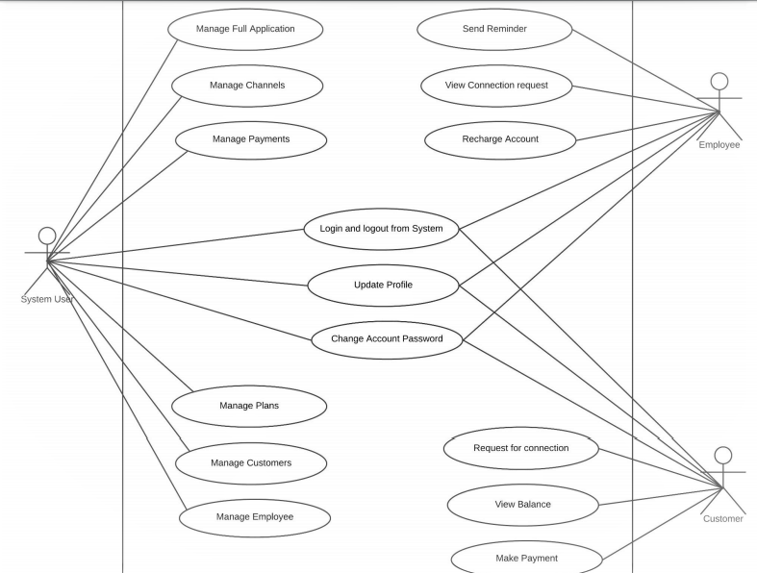

* **Activity Diagram**:

Customer /Employee

Start

st

start

Start

Login

No

Check

Yes

Logout

Type

Type

Employee

Customer

Home

* **Component Diagram**:

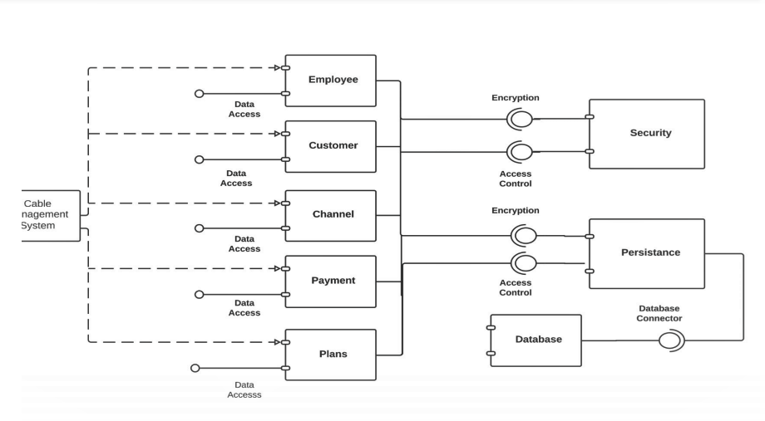

* **Sequence** **Diagram**:

